FIRSTGIVING fundraising for Da Yooper Plunge!
FirstGiving is a quick and easy way to fundraise for yourself and/or your team!
Fundraise for Da Yooper Pooper Toilet Trot, Da Yooper Plunge, and/or Da Yooper CHILL-Y Cook-off!
Any one or up to all three events can be fundraised on one individual/team page. Each event has its own minimum fundraising amount but more than one can be raised on one page.
Create your own customized pledge-raising web page and distribute your link to friends, family, colleagues, etc. A great way to increase fundraising and awareness of the event.
http://www.firstgiving.com/yooperplunge/2018

- Click on “Join Now” – the green button in the upper right corner.
- Complete the “Create and Account” fields. It’s easy to do, takes minutes and requires no technical skills. Personalize your site with your own pictures, content, fundraising goal and URL.
- E-mail your family, friends and colleagues for support. They can donate quickly and securely on your page by credit or debit card from anywhere in the world.
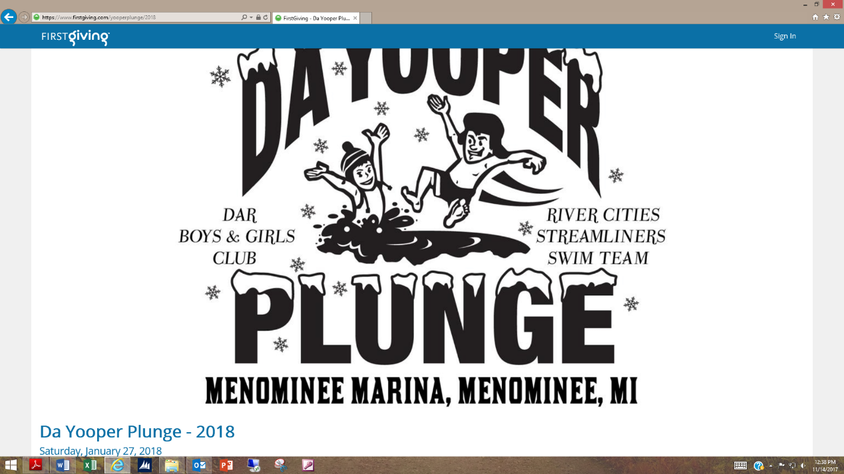
- Sit back and relax. No more chasing checks – funds are transferred automatically to the foundation's bank account so the money you raise starts making a difference right away.

